 | Bansilal Ramnath Agarwal Charitable Trust’s Vishwakarma Institute of Information Technology  Department of  Artificial Intelligence and Data Science
Student Name: Sathe Onkar Abasaheb
Class: TY | Division: B |  | Roll No.: 372078
Semester: V |  | Academic Year: 2025-2026
Subject Name & Code: Cyber Security (AD31234B)
Assignment No: 04
Title of Assignment: Compare symmetric and asymmetric key crypto system by referring to the appropriate use case with respect to the applicability and implement two algorithms of each type.
Date of Performance: 18/08/2025 |  | Date of Submission:25/08/2025

ASSIGNMENT NO. 04

Aim:
Compare symmetric and asymmetric key cryptosystem by referring to the appropriate use case with respect to the applicability and implement two algorithms of each type.

Objective: The objective of this assignment is to compare symmetric and asymmetric key cryptosystems, referring to appropriate use cases, and implement two algorithms of each type.

Materials Required:
Computer with Python programming environment.

Procedure:

1. Introduction

a. Overview of Symmetric and Asymmetric Key Cryptosystems
Cryptography is the science of securing communication and data through encryption. Two fundamental types of cryptographic systems are symmetric key cryptosystems and asymmetric key cryptosystems.
Symmetric Key Cryptosystems use a single key for both encryption and decryption. The sender and receiver share the same secret key, which must be kept confidential from any third party. Common symmetric algorithms include AES (Advanced Encryption Standard), DES (Data Encryption Standard), Blowfish, and Triple DES.
Asymmetric Key Cryptosystems, also called public-key cryptosystems, use a pair of mathematically linked keys: a public key and a private key. The public key is shared openly and used for encryption, while the private key is kept secret and used for decryption. Examples include RSA (Rivest-Shamir-Adleman), ElGamal, and ECC (Elliptic Curve Cryptography).

b. Differences between Symmetric and Asymmetric Encryption Algorithms
Feature | Symmetric Key Cryptosystem | Asymmetric Key Cryptosystem
Number of keys | Single shared secret key | Key pair: public key (encrypt), private key (decrypt)
Speed | Generally faster due to simpler algorithms | Slower due to complex mathematical operations
Key distribution | Requires secure key exchange channels | Public key can be distributed openly
Use cases | Bulk data encryption, real-time encryption | Secure key exchange, digital signatures, email encryption
Security dependency | Key secrecy and secure key exchange | Security relies on the difficulty of solving mathematical problems like factoring large numbers or discrete logarithms

c. Strengths and Limitations of Each Type

Symmetric Key Cryptosystems:
Strengths: Efficient and fast, suitable for encrypting large amounts of data.
Limitations: Key distribution problem; both parties must securely exchange and manage the same secret key, which can be a risk.
Asymmetric Key Cryptosystems:
Strengths: Simplifies key distribution by allowing public sharing of the encryption key. Provides features like digital signatures and non-repudiation.
Limitations: Computationally intensive, slower than symmetric cryptography, and usually less efficient for encrypting large data volumes.

2. Use Case Comparison

a. Use Case for Symmetric Key Cryptosystem
Use Case: Encrypting data stored on a local hard drive.
In this scenario, a symmetric key cryptosystem like AES is appropriate because the data owner encrypts and decrypts the data on the same device or within a trusted environment.
The symmetric key can be securely stored or derived from user credentials.
The speed and efficiency of symmetric encryption ensure minimal performance impact.

b. Use Case for Asymmetric Key Cryptosystem
Use Case: Secure email communication between two users.
Asymmetric cryptosystems like RSA enable one user to encrypt a message with the recipient’s public key, ensuring only the recipient can decrypt it with their private key.
This eliminates the need for a prior secure exchange of secret keys.
Additionally, digital signatures can verify the sender's identity.

3. Symmetric Key Cryptosystem

a. Selected Algorithms: AES and DES
AES is a widely used symmetric encryption standard with variable key sizes (128, 192, 256 bits) and strong security.
DES is an older standard using a 56-bit key; it is now largely considered insecure but serves educational purposes.

b. Implementation Overview
Encryption steps involve plaintext padding (if required), key scheduling, and block cipher operations.
Decryption reverses the process to retrieve the original plaintext.
Python libraries like pycryptodome or cryptography provide APIs for these algorithms.

c. Security and Efficiency
AES offers strong security against modern cryptanalysis with high throughput, making it ideal for real-time data encryption.
DES is vulnerable to brute-force attacks due to its short key length and is thus obsolete for secure applications.

4. Asymmetric Key Cryptosystem

a. Selected Algorithms: RSA and ElGamal
RSA is based on the difficulty of factoring large composite numbers.
ElGamal relies on the discrete logarithm problem and provides semantic security.

b. Implementation Overview
Key generation involves generating large primes and computing related parameters.
Encryption uses the recipient’s public key, while decryption uses the private key.
Python libraries such as pycryptodome or custom implementations using sympy and random modules can be used.

c. Security and Computational Complexity
RSA’s security depends on key size; larger keys offer stronger security but increase computation time.
ElGamal provides strong security guarantees but is computationally more expensive than RSA.
Both algorithms are inefficient for encrypting large data, hence often used for encrypting small data blocks or keys.

5. Comparison and Contrast
Aspect | Symmetric Key Cryptosystems | Asymmetric Key Cryptosystems
Security Properties | Relies on key secrecy; vulnerable to key leakage | Based on mathematical hardness assumptions; supports digital signatures
Key Management | Difficult due to secure key exchange | Easier due to public key distribution
Computational  Complexity | Low,  fast encryption/decryption | High, slower encryption/decryption
Suitability | Bulk data encryption, real-time applications | Secure key exchange, authentication, digital signatures
Example Use Case | Disk encryption, VPN | Email encryption, SSL/TLS handshake

Input/Output :

1.AES:
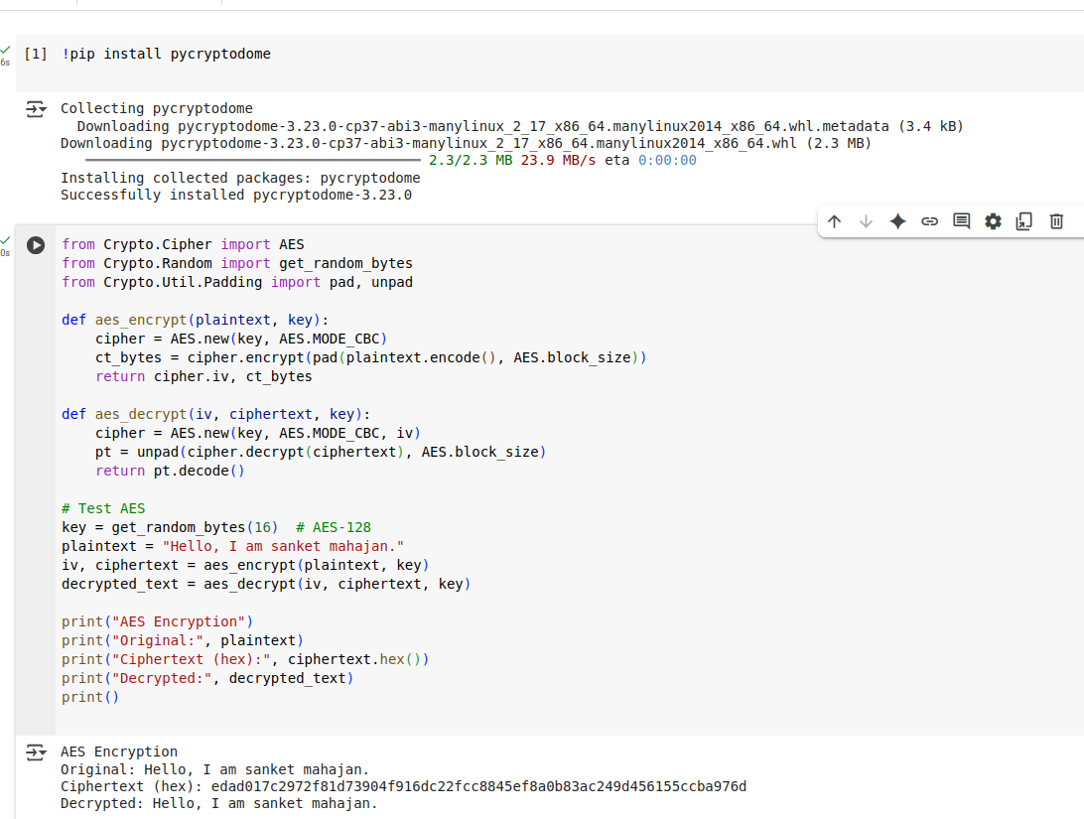

2.RSA:

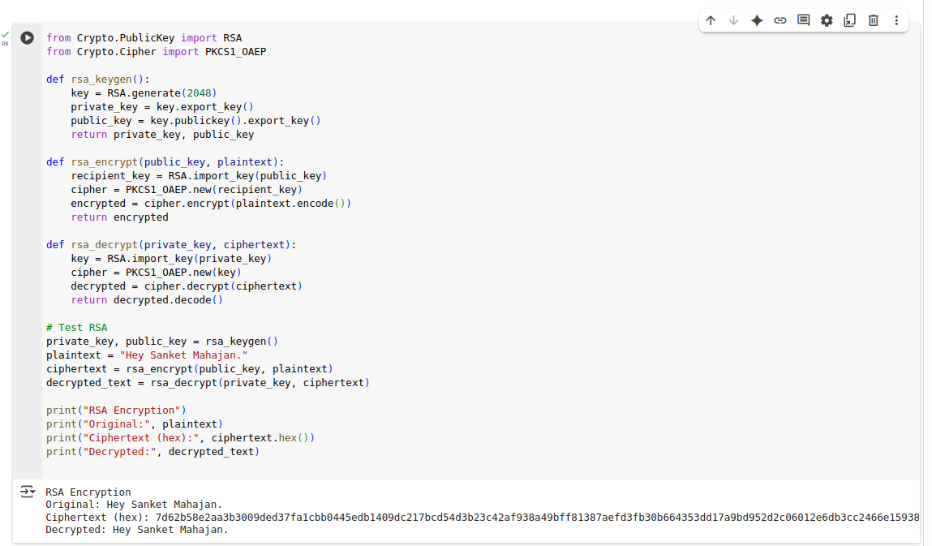

Conclusion:
This assignment highlights the fundamental differences between symmetric and asymmetric key cryptosystems. Symmetric algorithms like AES offer efficient encryption suited for large data volumes but suffer from key distribution challenges. Asymmetric algorithms like RSA solve the key distribution problem and provide additional security features at the cost of computational complexity.
Understanding these systems' appropriate use cases is crucial for designing secure communication protocols. Proper key management remains the backbone of any cryptographic system's security. As cryptography advances, hybrid systems combining symmetric and asymmetric methods (e.g., using asymmetric keys to exchange symmetric session keys) are prevalent, balancing security and efficiency.

